

**Excel Assignment - 6**

1. **What are the various elements of the Excel interface? Describe how they're used.**

-The various elements of the Excel interface include:

Ribbon: The ribbon is located at the top of the Excel window and contains tabs that organize the various commands and features of Excel. Each tab is further divided into groups, making it easy to access specific functions.

File Tab: Located in the top-left corner of the ribbon, the File tab provides access to file management options such as opening, saving, printing, and sharing files. It also allows you to customize Excel options and access document properties.

Quick Access Toolbar: This toolbar is located above the ribbon and provides quick access to frequently used commands. You can customize the toolbar by adding or removing commands according to your preferences.

Formula Bar: The formula bar, located below the ribbon, displays the contents of the currently selected cell. You can enter or edit formulas and data directly in the formula bar.

Worksheets: Excel workbooks consist of multiple worksheets, which are displayed as tabs at the bottom of the Excel window. Worksheets are used to organize and analyze data. You can add, delete, rename, and rearrange worksheets as needed.

Columns and Rows: Excel uses a grid system, with columns labeled alphabetically (A, B, C, etc.) and rows labeled numerically (1, 2, 3, etc.). Columns are used to organize data horizontally, while rows are used vertically

Cells: The intersection of a column and a row forms a cell. Cells are used to store data, formulas, and functions. They can contain numbers, text, dates, and other types of information.

Formulas and Functions: Excel allows you to perform calculations and data analysis using formulas and functions. Formulas are equations that use cell references, operators, and functions to perform calculations. Functions are predefined formulas that simplify common calculations.

1. **Write down the various applications of Excel in the industry.**

**-**Excel has various applications in different industries, including:

Financial Analysis and Accounting: Excel is widely used for financial analysis, budgeting, financial modeling, and accounting tasks. It allows professionals to track expenses, create balance sheets, perform financial calculations, and generate reports.

Data Analysis and Reporting: Excel provides powerful tools for data analysis and visualization. It enables professionals to import, clean, analyze, and visualize large datasets. It offers features such as sorting, filtering, pivot tables, charts, and conditional formatting.

Project Management: Excel can be used to create project plans, track project progress, manage budgets, and create Gantt charts. It allows project managers to organize tasks, allocate resources, and monitor project timelines.

Sales and Marketing: Excel is utilized for sales forecasting, lead tracking, customer data management, and marketing campaign analysis. It enables professionals to analyze sales trends, calculate sales metrics, and create sales reports.

Human Resources: Excel is employed in HR departments for tasks such as employee data management, payroll processing, attendance tracking, and performance evaluation. It facilitates organizing and analyzing HR-related data.

Inventory Management: Excel can be used to track inventory levels, manage stock, and create inventory reports. It allows businesses to monitor product quantities, analyze sales patterns, and streamline inventory management processes.

Data Visualization and Dashboards: Excel offers a variety of chart types and visualization options. It is often used to create interactive dashboards and reports, enabling users to summarize and present data in a visually appealing manner.

1. **On the ribbon, make a new tab. Add some different groups, insert commands in the groups and name them according to the commands added. Copy and paste the screenshot of the steps you followed.**

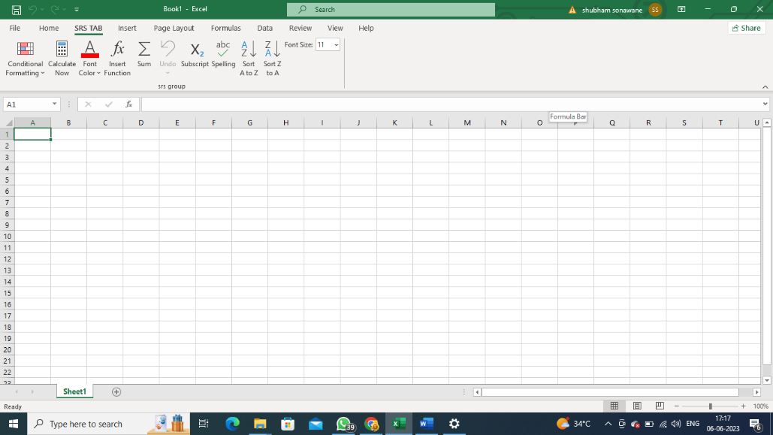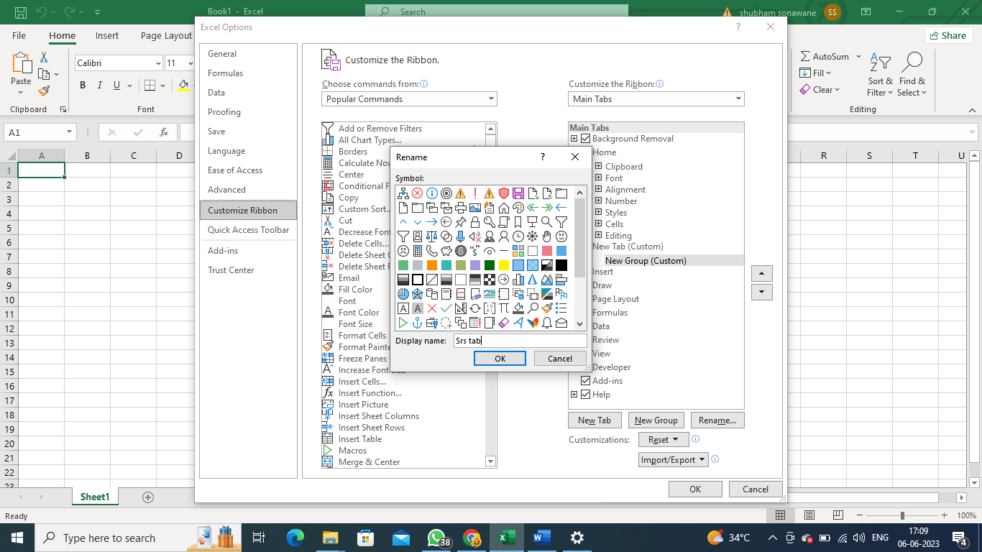

1. **Make a list of different shortcut keys that are only connected to formatting with their functions.**

-Here is a list of some formatting-related shortcut keys in Excel:

Ctrl+B: Bold

Ctrl+I: Italic

Ctrl+U: Underline

Ctrl+Shift+F: Apply the Accounting format

Ctrl+Shift+~: Apply the General format

Ctrl+Shift+$: Apply the Currency format

Ctrl+Shift+%: Apply the Percentage format

Ctrl+Shift+#: Apply the Date format

Ctrl+Shift+@: Apply the Time format

Ctrl+Shift+!: Apply the Number format

Ctrl+Shift+^: Apply the Scientific format

Ctrl+Shift+_: Remove the border from the selected cells

Ctrl+1: Open the Format Cells dialog box

Ctrl+Shift+P: Apply point border

Ctrl+Shift+L: Apply the filter

1. **What distinguishes Excel from other analytical tools?**

**-**Excel distinguishes itself from other analytical tools in several ways:

Spreadsheet Functionality: Excel provides a comprehensive spreadsheet environment that allows users to organize, analyze, and manipulate data in a tabular format. Its grid system, formulas, functions, and data manipulation features make it a versatile tool for data analysis and modeling.

Familiar User Interface: Excel has a user-friendly interface that is widely recognized and used across industries. Many professionals are already familiar with Excel, making it an accessible and widely adopted tool for data analysis.

Customization and Automation: Excel offers extensive customization options, allowing users to tailor their worksheets, charts, and reports according to their specific needs. It also supports automation through macros, Visual Basic for Applications (VBA), and add-ins, enabling users to automate repetitive tasks and create custom solutions.

Integration with Other Tools: Excel can seamlessly integrate with other Microsoft Office applications, such as Word and PowerPoint. It also supports data import and export from various formats, allowing users to work with data from different sources.

Broad Range of Functions: Excel provides a wide range of built-in functions and formulas for performing complex calculations, statistical analysis, financial modeling, and more. Additionally, users can create their own custom functions using VBA.

Collaboration and Sharing: Excel allows multiple users to work on the same workbook simultaneously, facilitating collaboration and teamwork. It also offers features for sharing and protecting workbooks, controlling access, and tracking changes.

Visualizations and Reporting: Excel includes a variety of chart types and visualization options, enabling users to create visually appealing reports and dashboards. It supports conditional formatting, data bars, sparklines, and other visual elements to enhance data presentation.

1. **Create a table and add a custom header and footer to your table.**

**-**